Name: Lujain Zia
Roll no: 2023-BSE-034
Date: November 21, 2025

Lab 8
Task 1 — Create an AWS account and enable UAE (me-central-1)

- Open your browser and go to: AWS Signup
Save screenshot as: task1_open_signup_page.png — browser showing the signup page.
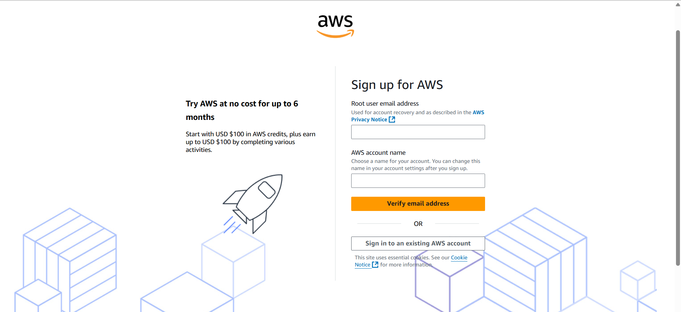
- Complete registration (Account type: Personal, Plan: AWS Paid Plan), fill contact, billing (credit card) and phone details, complete verification. After successful registration capture:
Save screenshot as: task1_signed_up_confirmation.png — registration success/confirmation page or payment confirmation (do NOT include credit card full details).
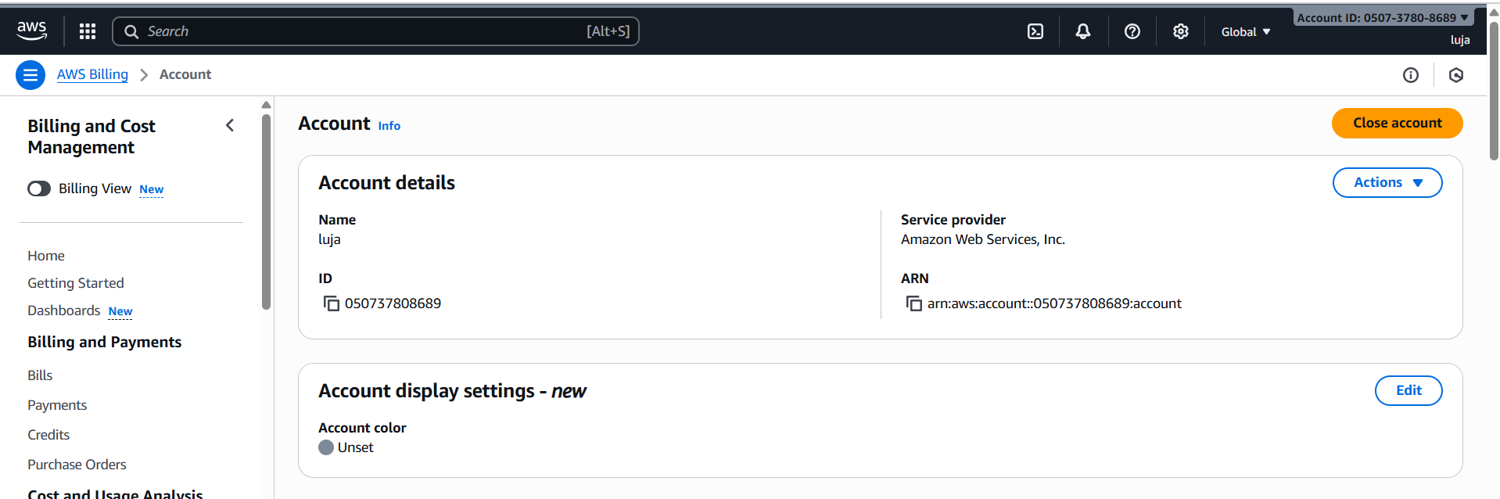
- Sign in as the root user (root email). Immediately capture:
Save screenshot as: task1_root_signed_in.png — AWS Console Home after root login (top bar with root email/account alias visible).
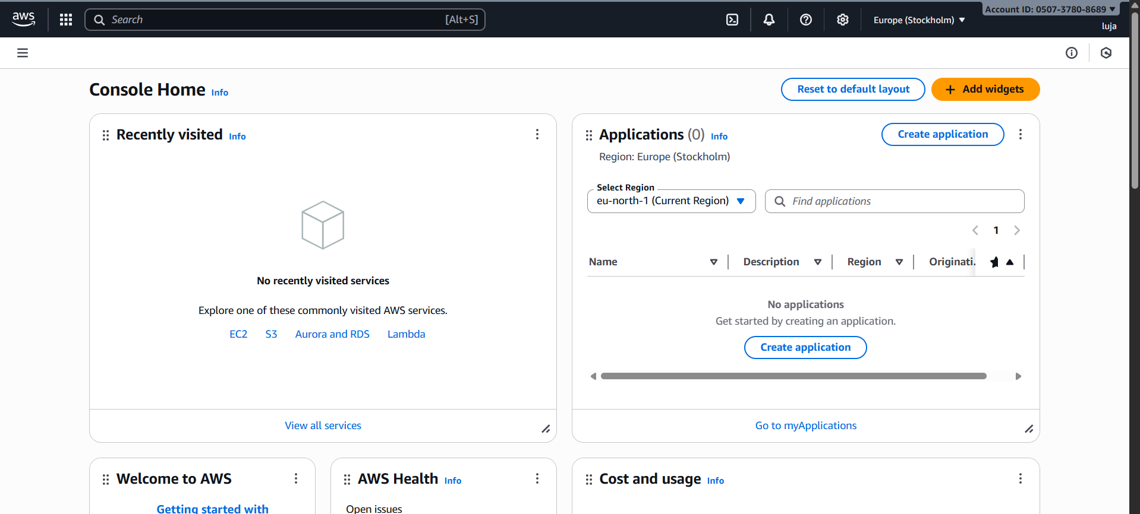
- From the Console, open the region selector and enable UAE (me-central-1), then switch to me-central-1. Capture the change
Save screenshot as: task1_enable_region_me-central-1.png — region selector showing me-central-1 selected.
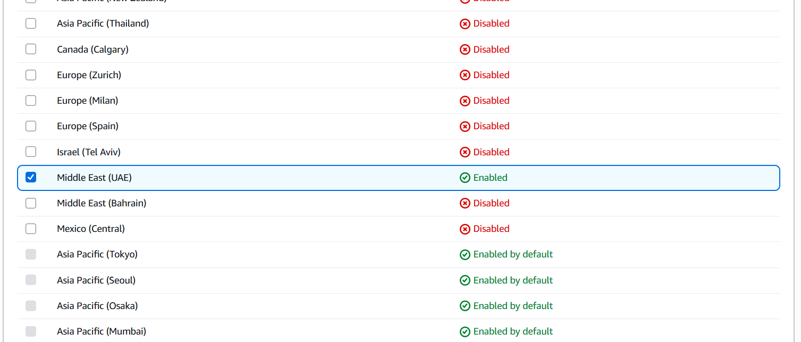
- Task 1 summary screenshot (combine evidence):
Save screenshot as: task1_summary.png — single screenshot showing root console header (root email/account alias) and region set to me-central-1.

Task 2 — Create IAM Admin and Lab8User with console access

- Open IAM via Console search (Alt+S → "IAM").
Save screenshot as: task2_open_iam_console.png — IAM console landing page (region me-central-1 visible).
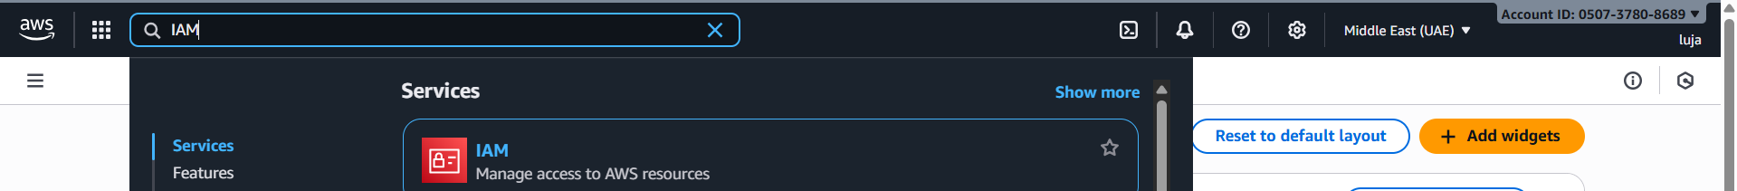
- Create the Admin user: IAM → Users → Create user. Fill:
Username: Admin
Provide user access to the AWS Management Console
Set console password (autogenerate or set)
Attach policies directly → AdministratorAccess
Capture the completion screen when user is created:
Save screenshot as: task2_admin_create_confirmation.png — IAM "Create user" success screen showing Admin (do NOT include password).
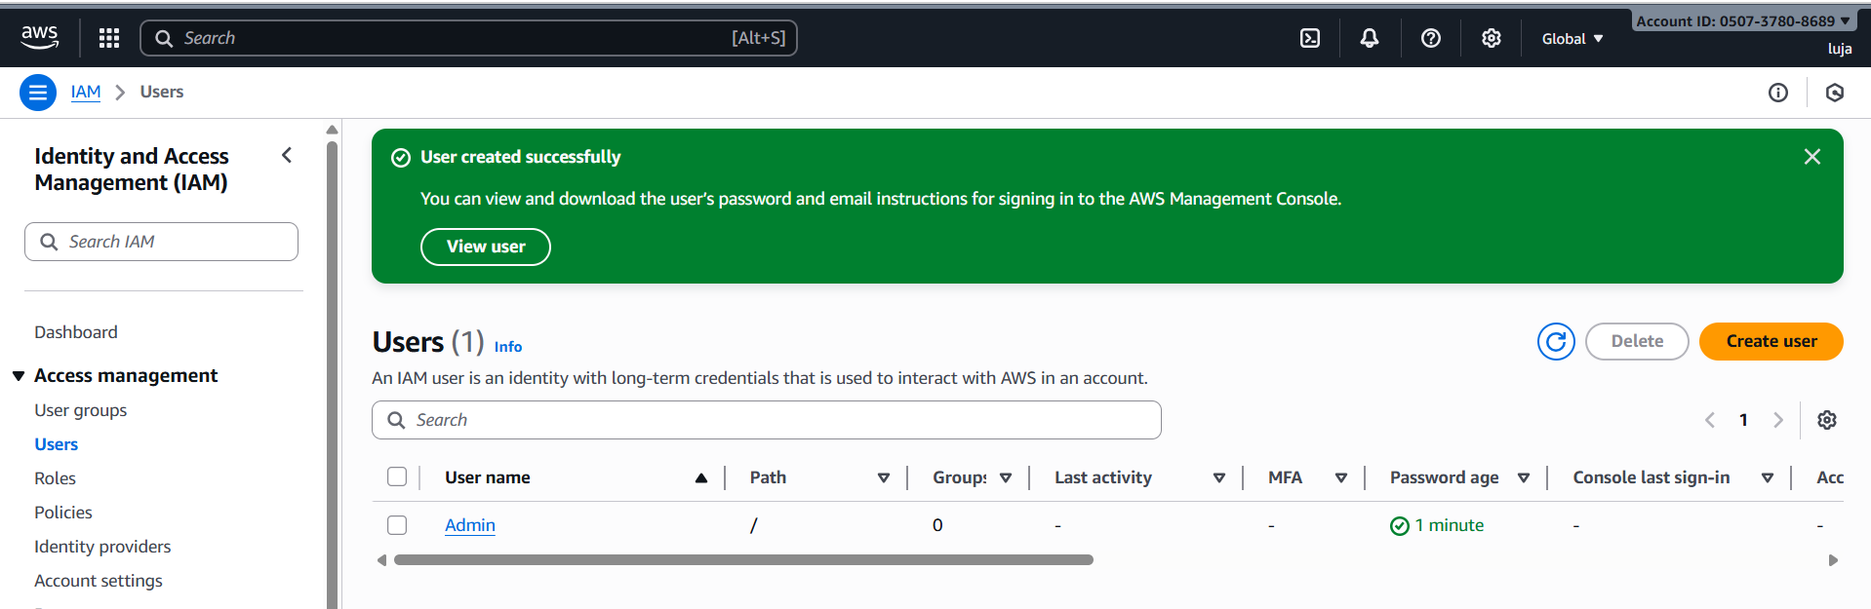
- Download the Admin .csv and show its presence on your Windows host (do not display the password text):
Save screenshot as: task2_admin_csv_and_signin_url.png — Windows File Explorer showing the downloaded CSV filename and/or a cropped view of the CSV showing only the Sign-in URL and username (redact the password if visible).
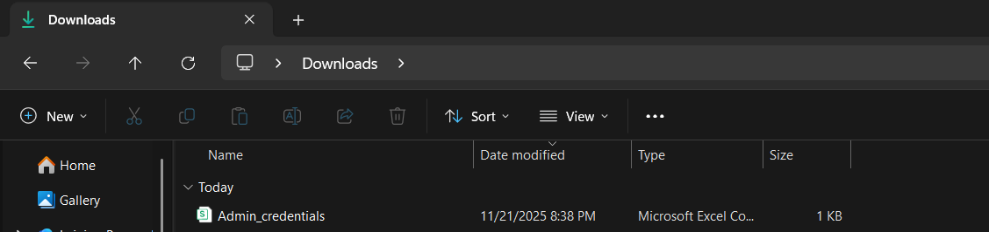
- Sign out of root, then sign in using the Admin account (use the signin URL from the .csv). Capture after successful Admin login:
Save screenshot as: task2_admin_console_after_login.png — Admin user console home.
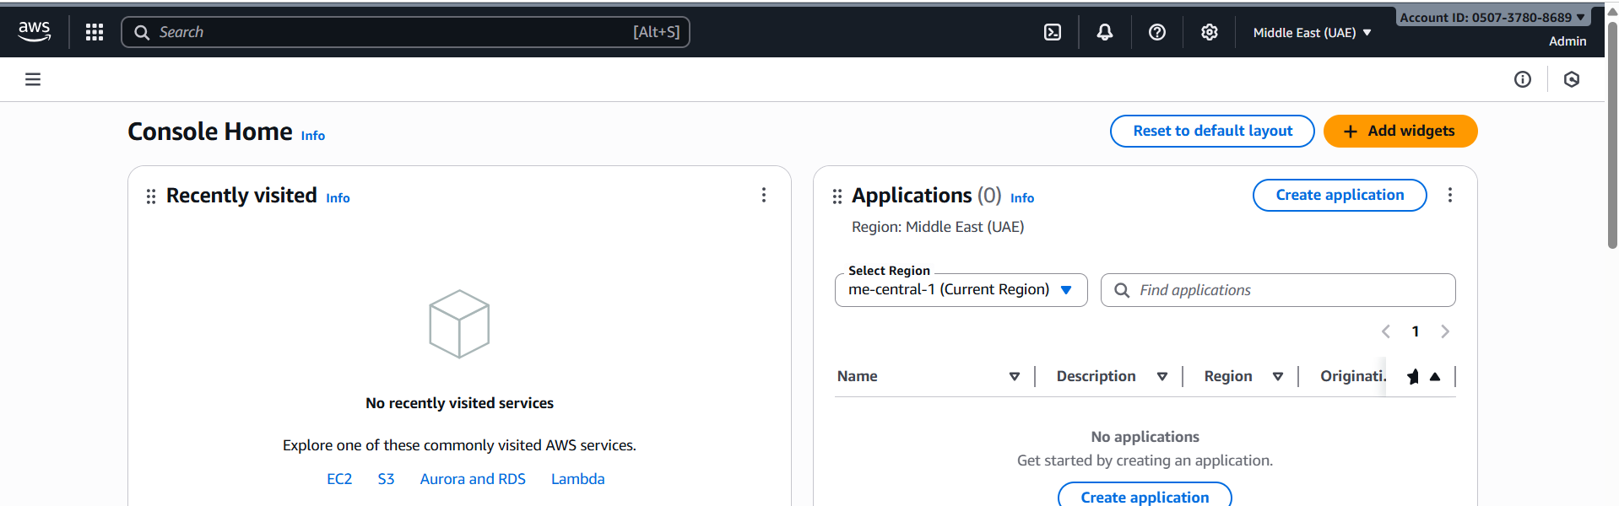
- While logged in as Admin, create Lab8User:

IAM → Users → Create user
Username: Lab8User
Provide user access to the AWS Management Console
Attach AdministratorAccess policy
Capture the create-user success screen:
Save screenshot as: task2_create_lab8user_and_csv.png — Lab8User create confirmation and CSV download prompt (do NOT include password).
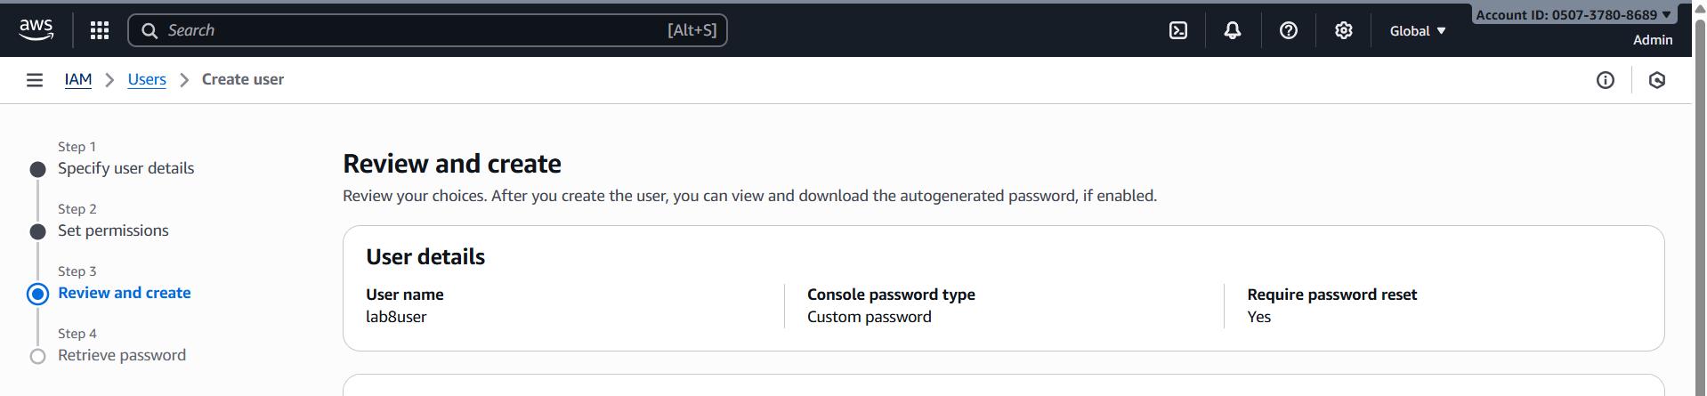
- Download/save the Lab8User CSV on your Windows host (do not show password).
Save screenshot as: task2_lab8user_csv_saved.png — File Explorer showing the Lab8User CSV filename (cropped to exclude sensitive content).
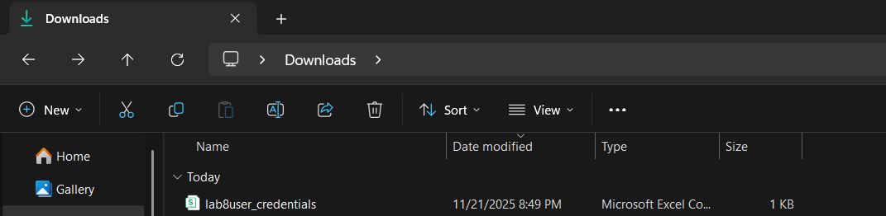
- Logout Admin and login as Lab8User (use the Lab8User signin URL and credentials). Capture after login:
Save screenshot as: task2_lab8user_logged_in.png — Lab8User console home.
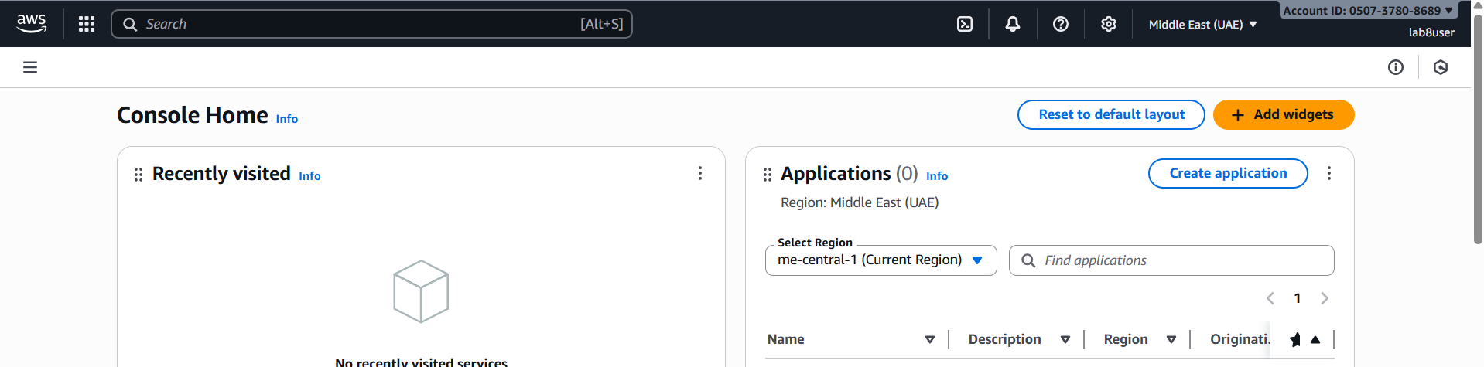
- Task 2 summary (combine evidence):
Save screenshot as: task2_summary.png — IAM Users list showing both Admin and Lab8User present (region me-central-1 visible).
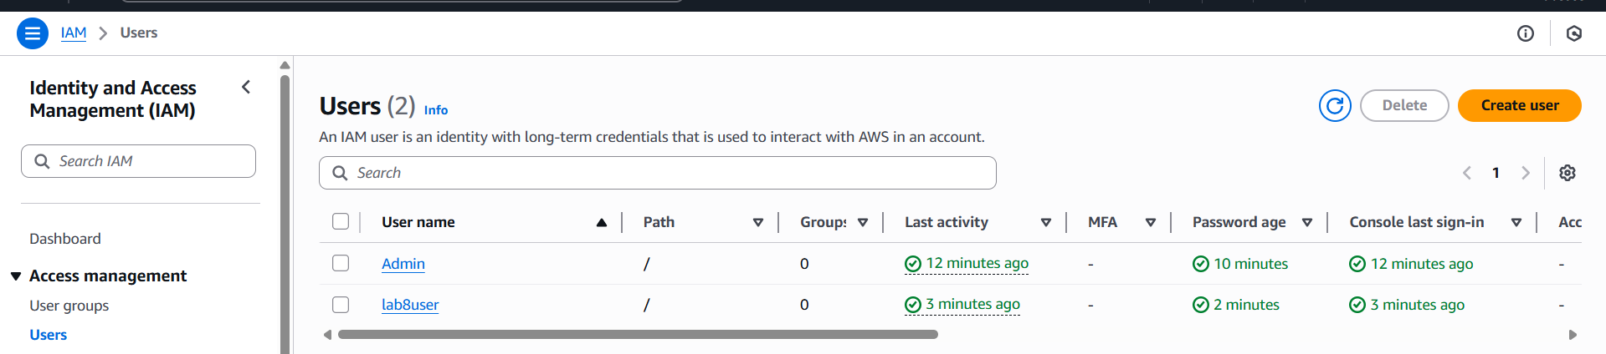
Task 3 — Inspect VPC resources (in UAE me-central-1)
- Open VPC console (Alt+S → "VPC") while region is me-central-1.
Save screenshot as: task3_open_vpc_console.png — VPC console landing page (region visible).
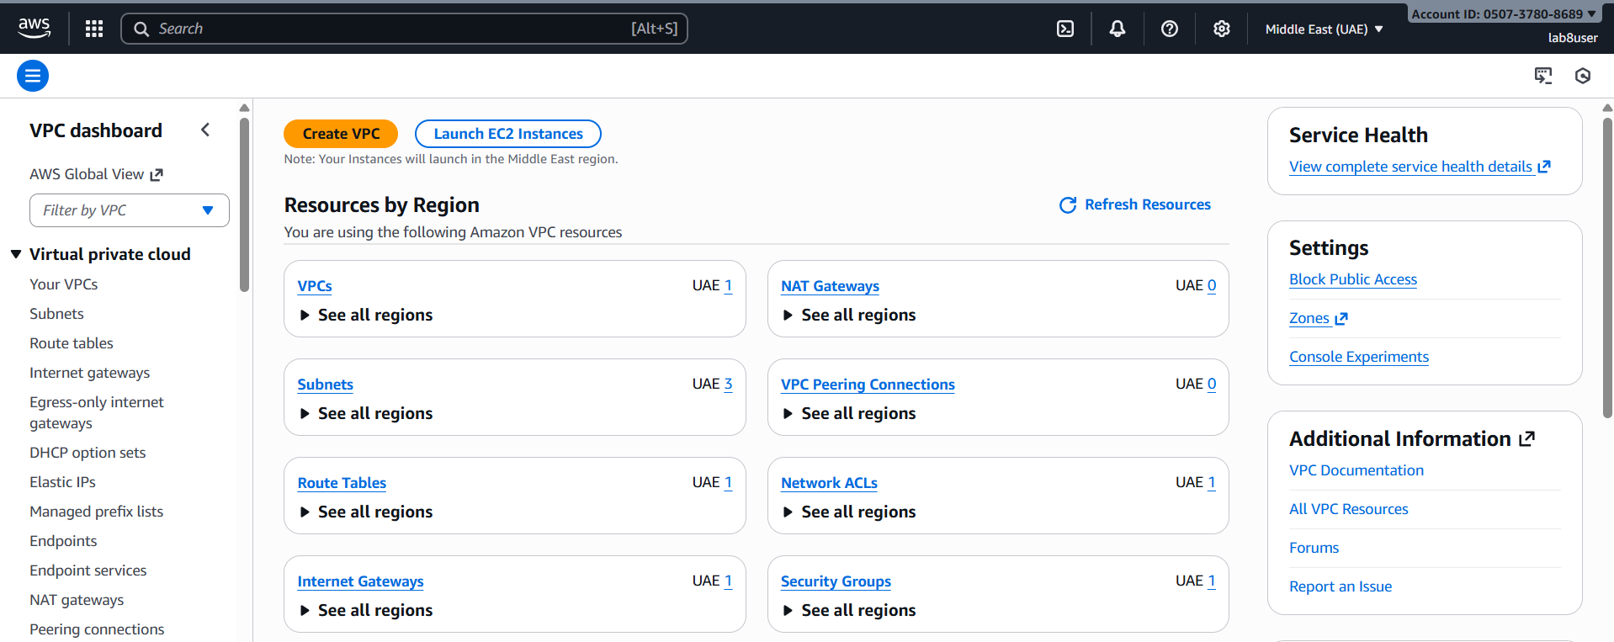
- View VPCs list. Capture:
Save screenshot as: task3_vpcs_list.png — VPCs list view (show default VPC if present).
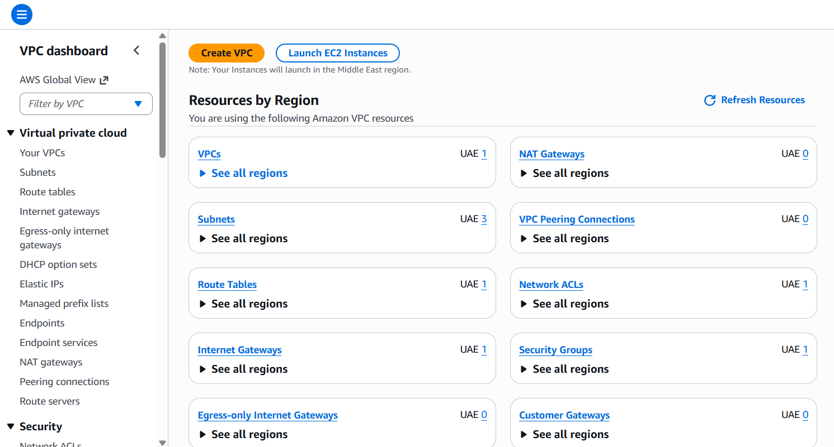
- View Subnets list. Capture:
Save screenshot as: task3_subnets_list.png — Subnets list view (show at least 3 default subnets if present).
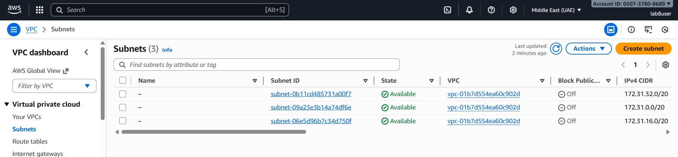
- View Route Tables list. Capture:
Save screenshot as: task3_route_tables_list.png — Route Tables list view.
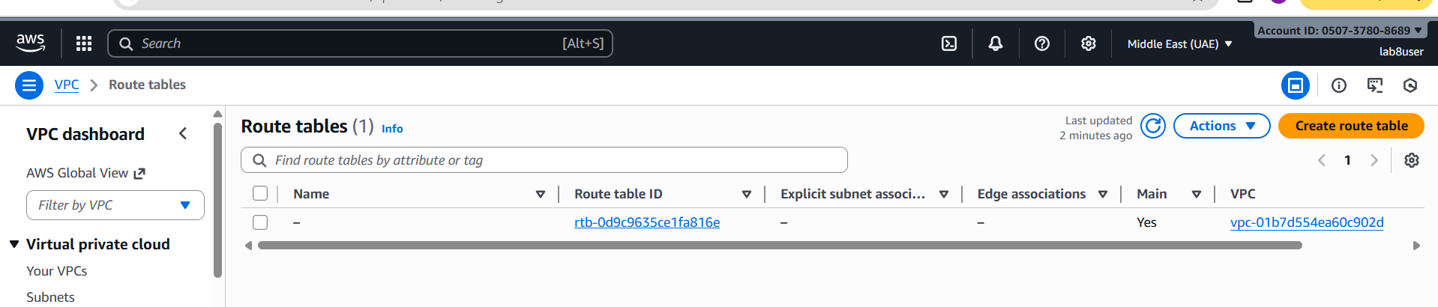
- View Network ACLs list. Capture:
Save screenshot as: task3_network_acls_list.png — Network ACLs list view.
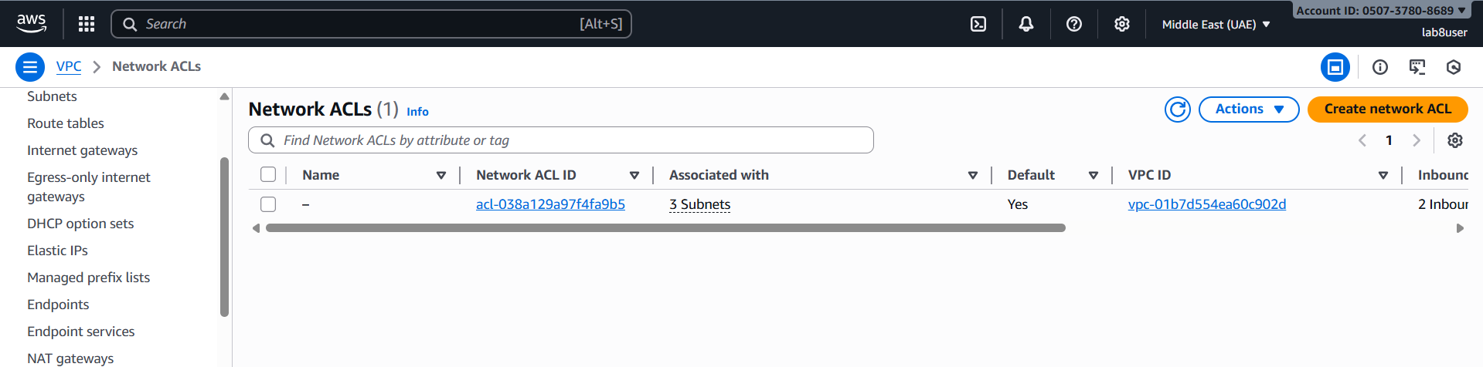
- Task 3 summary (combine evidence):
Save screenshot as: task3_summary.png — a single screenshot showing the VPC console left navigation and counts or multiple open tabs/windows tiled to show each resource's list (region me-central-1 visible).
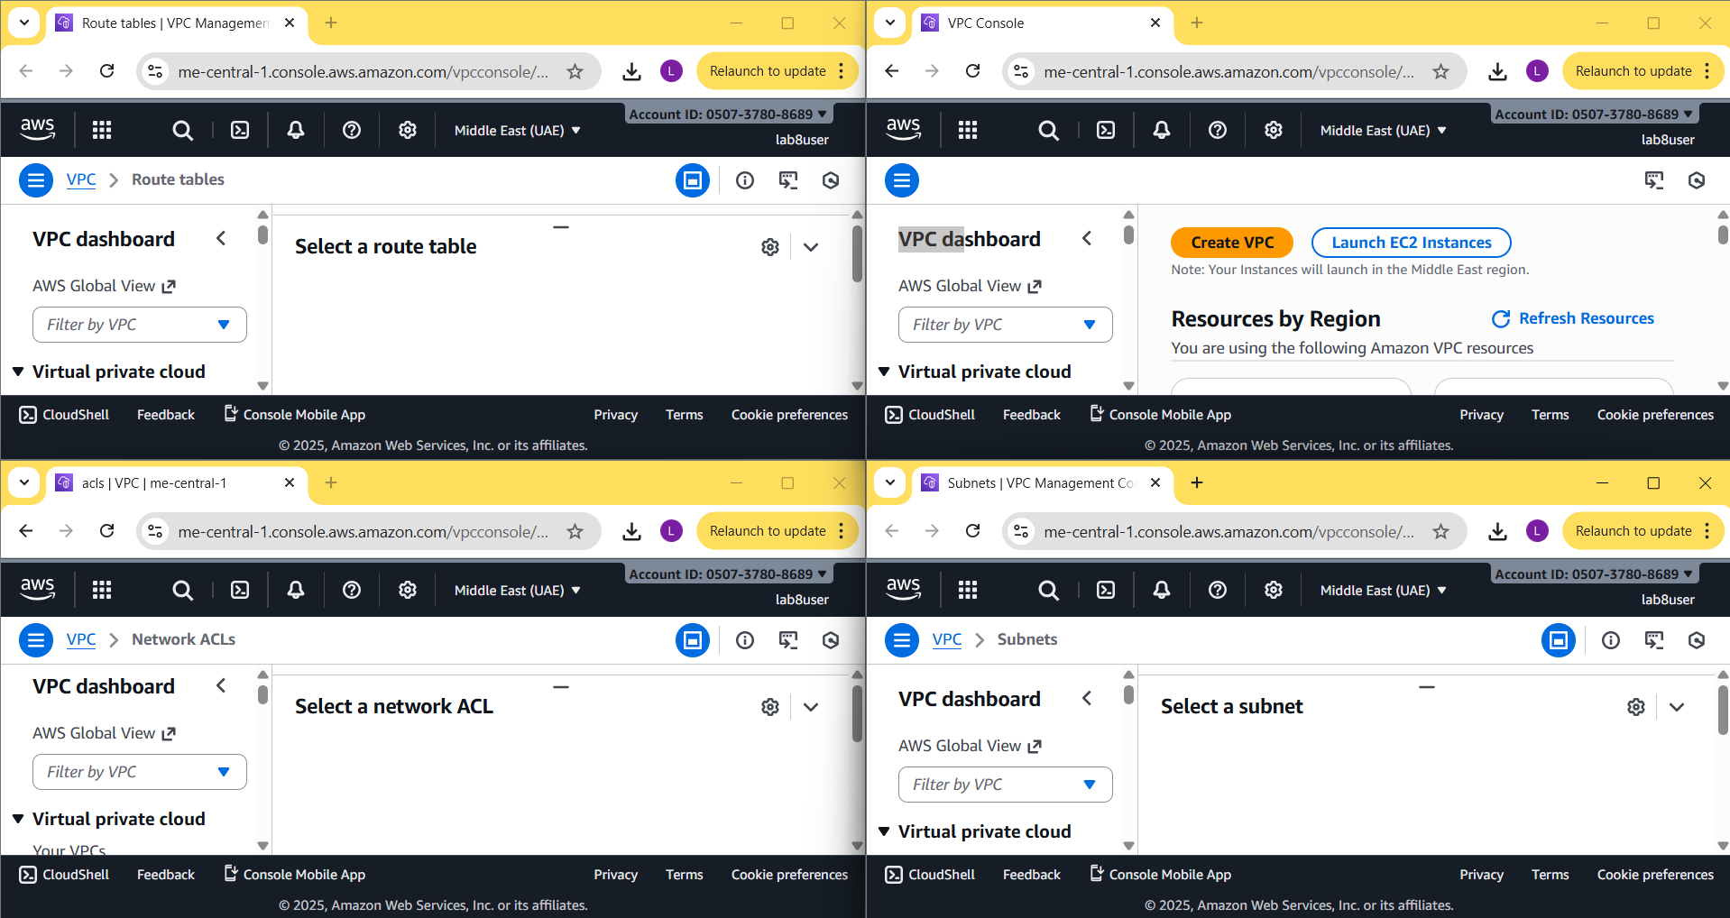
Task 4 — Launch EC2, SSH, install Docker & Docker Compose, deploy Gitea
- Open EC2 Console (Alt+S → "EC2") (me-central-1).
Save screenshot as: task4_open_ec2_console.png — EC2 console landing page with region visible.
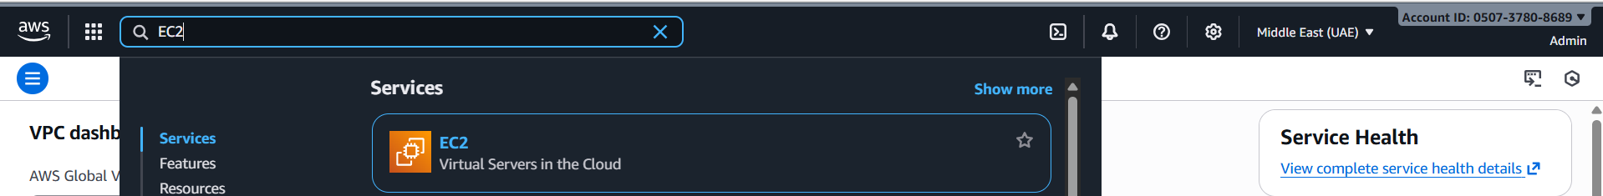

- Instance Launch configuration (during review before launching). Configure:
Name: Lab8Machine
AMI: Amazon Linux 2
Instance type: t2.micro
Security group: Create Lab8SecurityGroup with SSH from My IP
Storage: default
Key pair: Create Lab8Key (ED25519, .pem) and download the .pem file to your Windows host
Capture the final review page and the key download prompt:
Save screenshot as: task4_launch_instance_config.png — final review page showing instance name, AMI, type, security group, key pair.
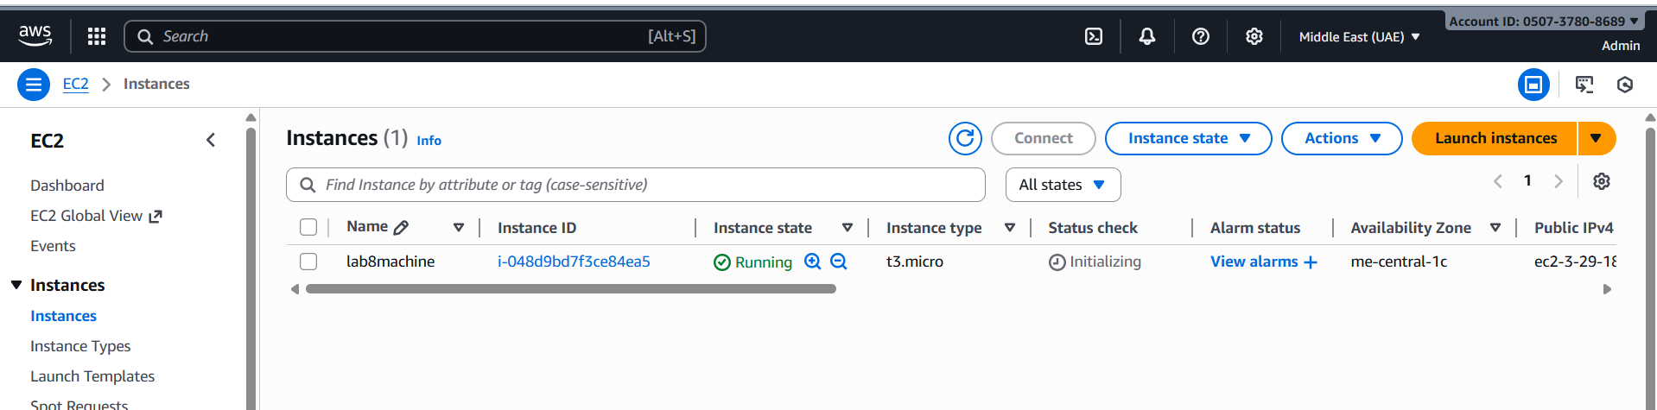
Save screenshot as: task4_keypair_download.png — Windows File Explorer showing Lab8Key.pem downloaded (do NOT open .pem contents).
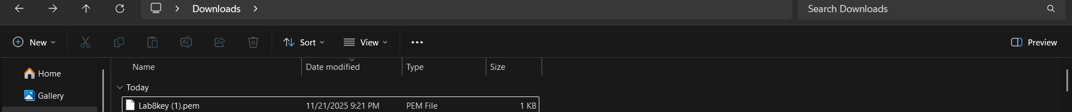
- After launch, EC2 Instances list showing Lab8Machine in "running" state and public IPv4 visible.
Save screenshot as: task4_instance_running_console.png — Instances table with Lab8Machine running and Public IPv4.
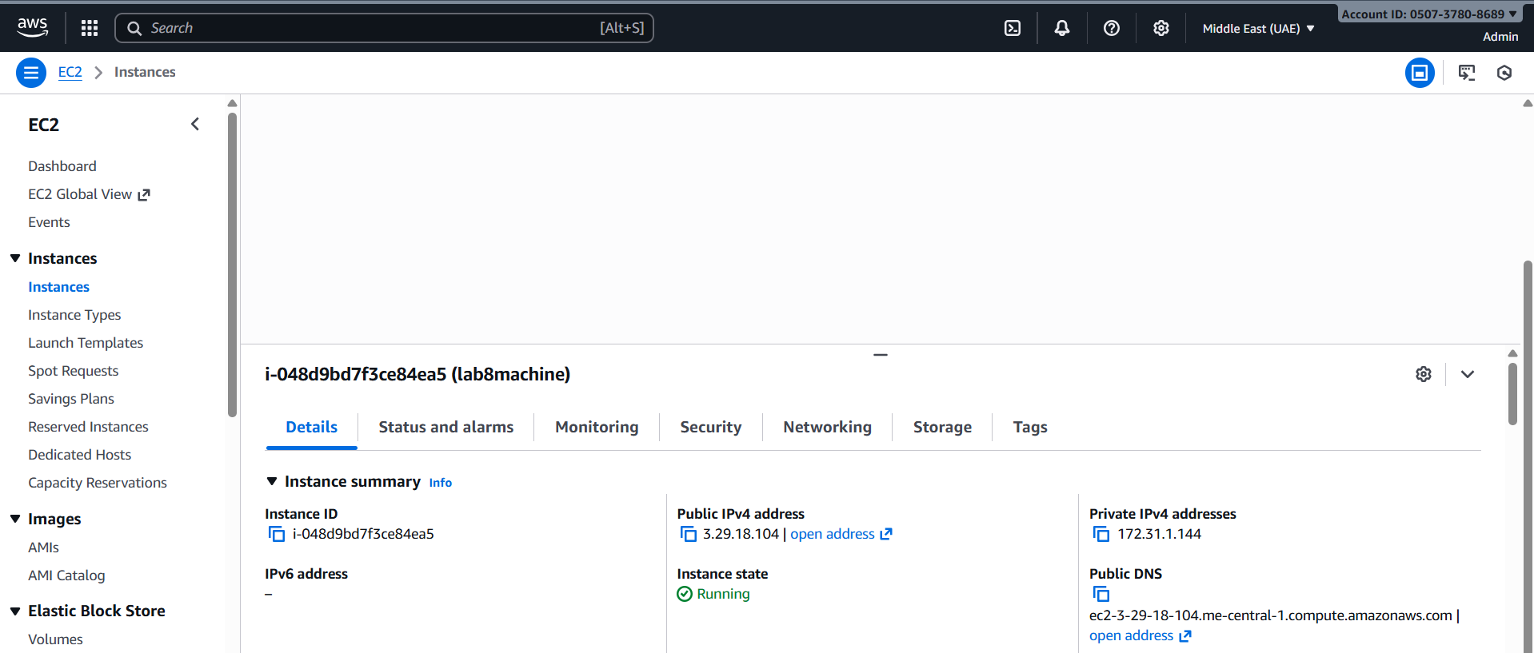
- On Windows host, run SSH using the downloaded .pem (PowerShell/Git Bash/Windows Terminal):

ssh -i <path>/Lab8Key.pem ec2-user@<public-IP>

Capture the SSH command and successful shell prompt on the EC2 instance:
Save screenshot as: task4_ssh_from_windows_to_ec2.png — PowerShell showing ssh command and EC2 shell (do NOT show private key contents).
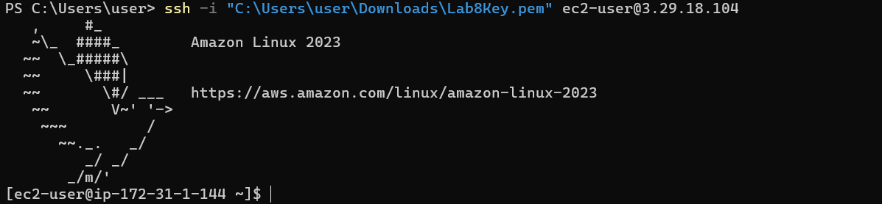
- Run the install commands on the EC2 shell:

sudo yum update -y
sudo yum install -y docker
sudo mkdir -p /usr/local/lib/docker/cli-plugins
sudo curl -SL https://github.com/docker/compose/releases/latest/download/docker-compose-linux-x86_64 -o /usr/local/lib/docker/cli-plugins/docker-compose
sudo chmod +x /usr/local/lib/docker/cli-plugins/docker-compose
sudo systemctl start docker
Capture the terminal showing these commands run and successful outputs:
Save screenshot as: task4_ec2_install_docker_compose_started.png — outputs of update/install and systemctl start.
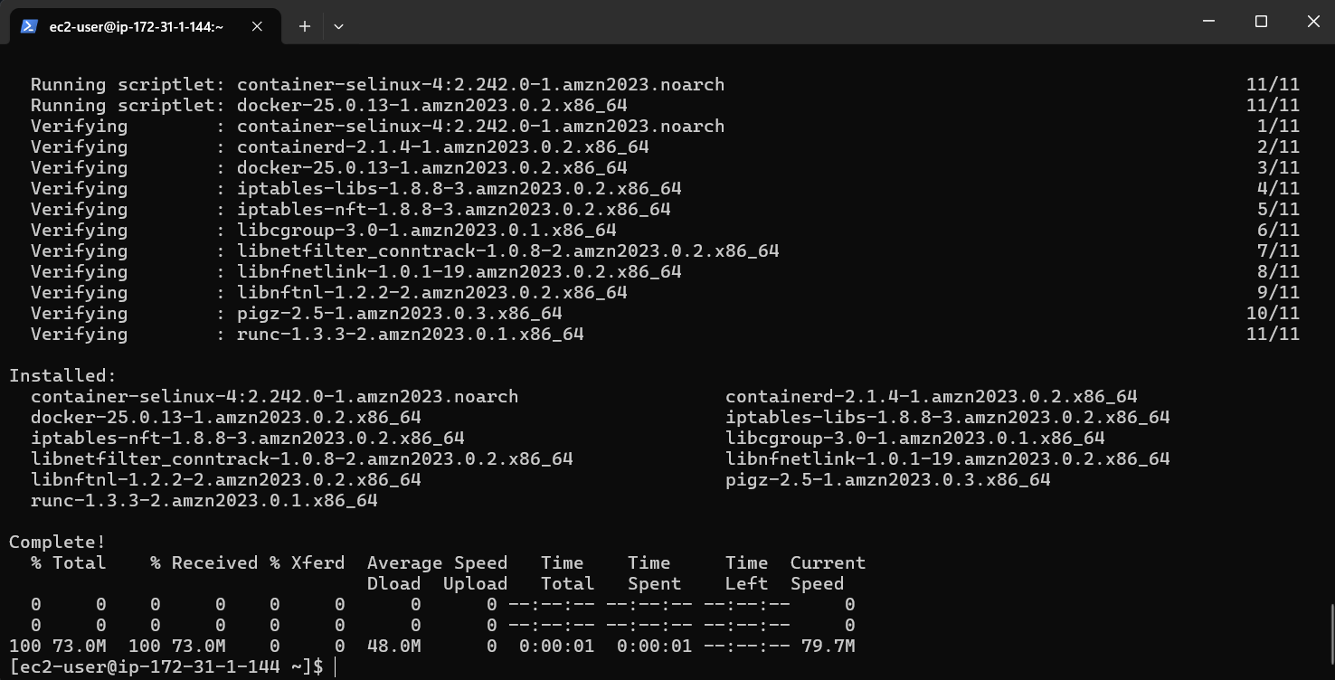
- Create/edit compose.yaml on the EC2 instance (sudo vim compose.yaml) and paste content from the repo: Gitea . While pasting, capture the editor content:
Save screenshot as: task4_vim_compose_yaml_paste.png — vim editor showing compose.yaml contents while pasted.
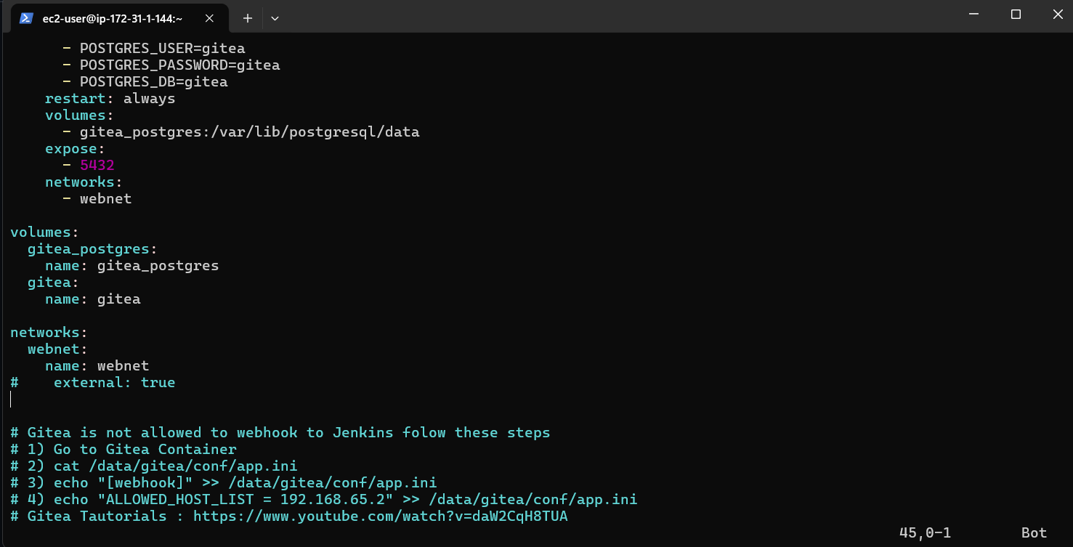
- Save and verify file exists:
Save screenshot as: task4_compose_yaml_saved_ls.png — ls -l showing compose.yaml present.
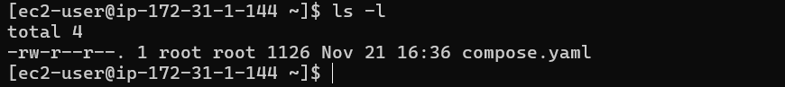
- Add ec2-user to docker group, show groups before re-login, exit and reconnect, show groups after reconnect:

groups # user does not docker permission
sudo usermod -aG docker $USER
groups # before re-loginexit# Reconnect
ssh -i <path>/Lab8Key.pem ec2-user@<public-IP>
groups # after re-login (should include docker)
Save screenshot as: task4_usermod_and_groups_before_after.png — show usermod command, groups output before exit, reconnect sequence, and groups output after (docker included).
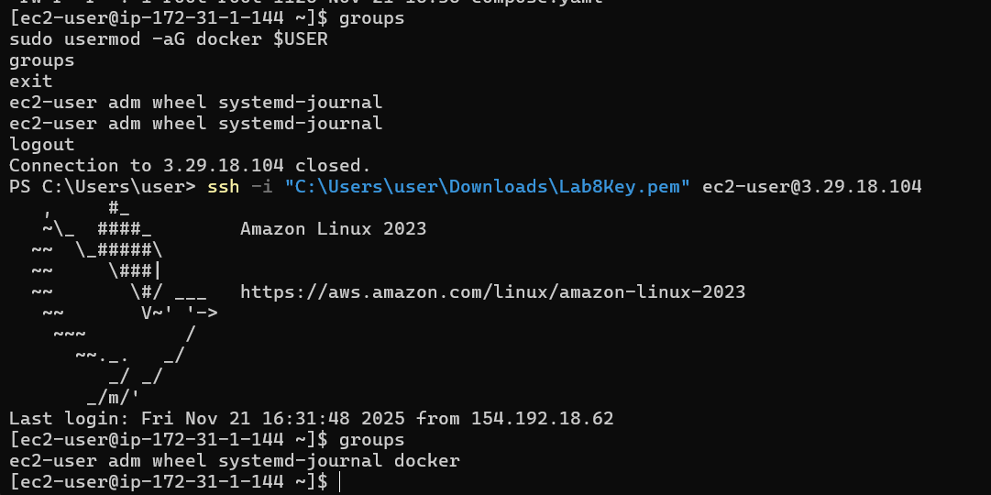
- Run docker compose up -d from the directory with compose.yaml:

docker compose up -d
Save screenshot as: task4_docker_compose_up.png — output of docker compose up -d showing containers starting.
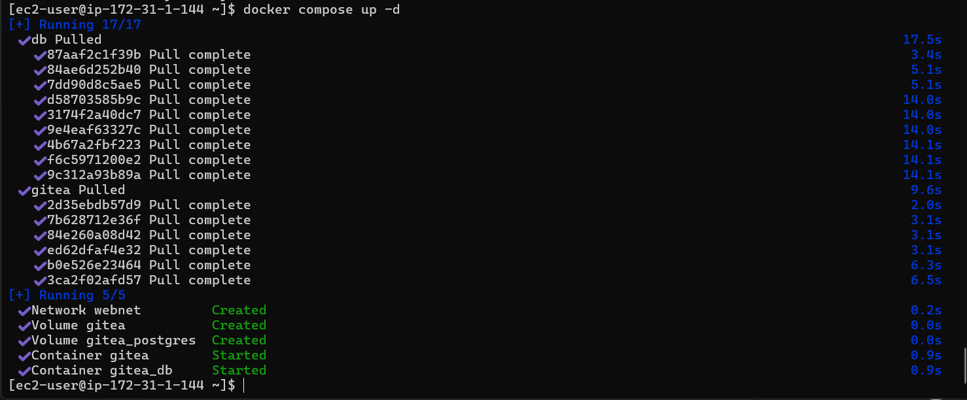
- Edit the security group Lab8SecurityGroup inbound rules in the EC2 console: add Custom TCP rule port 3000 source 0.0.0.0/0 and save. Capture the inbound rules after saving:
Save screenshot as: task4_security_group_allow_3000.png — security group inbound rules list showing SSH from My IP and Custom TCP 3000 anywhere.
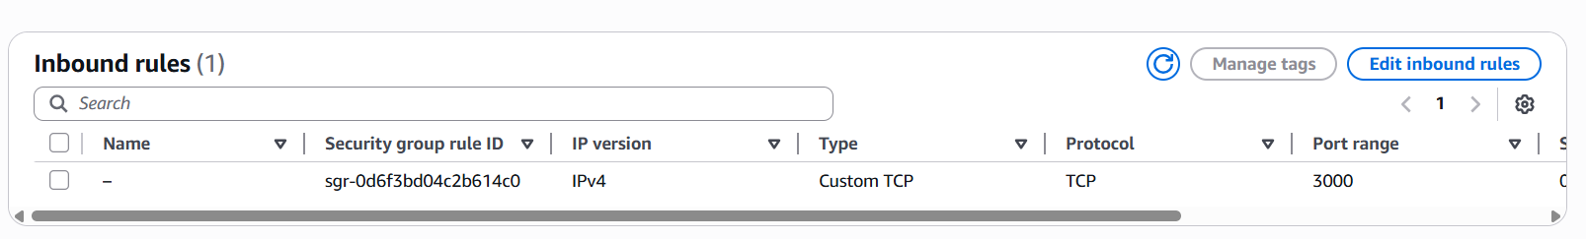
- From your Windows browser navigate to: http://Public-IP:3000 — capture the Gitea setup/install page:
Save screenshot as: task4_gitea_install_page.png — Gitea installation page in browser.
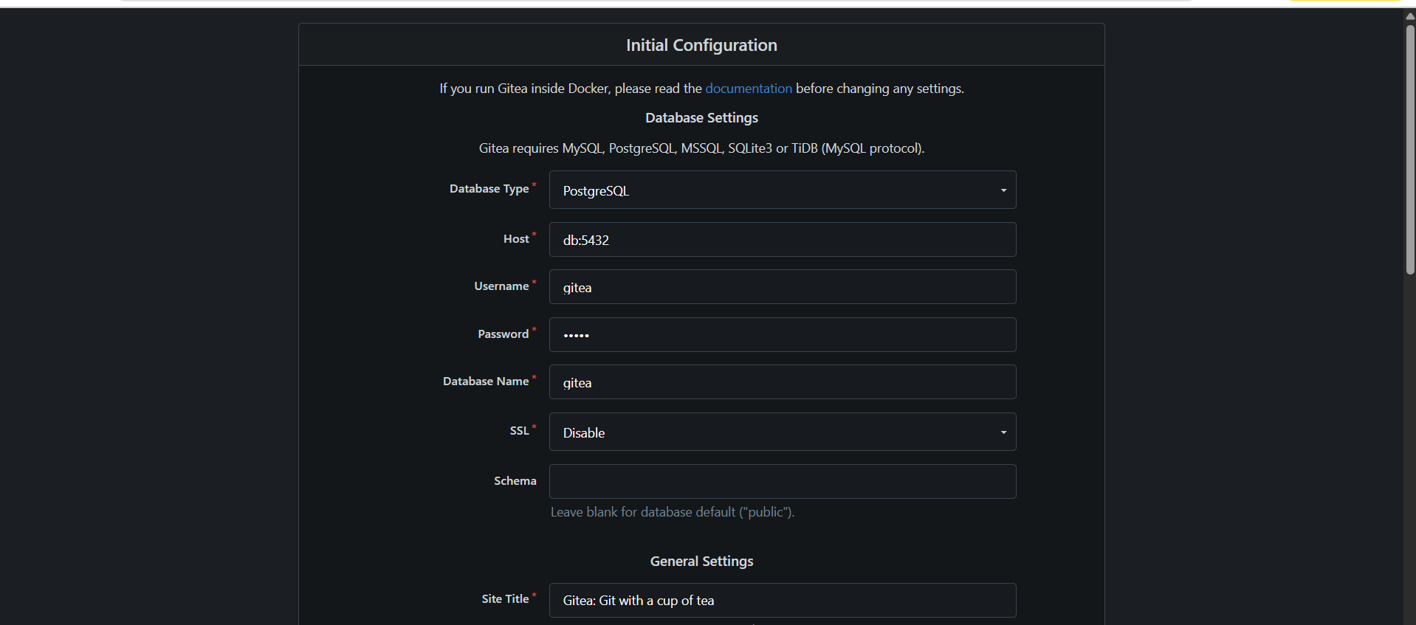
- Complete initial Gitea setup (create admin user, create a repo) and capture Gitea showing the created repository:
Save screenshot as: task4_gitea_create_repo.png — Gitea UI showing the created repository.
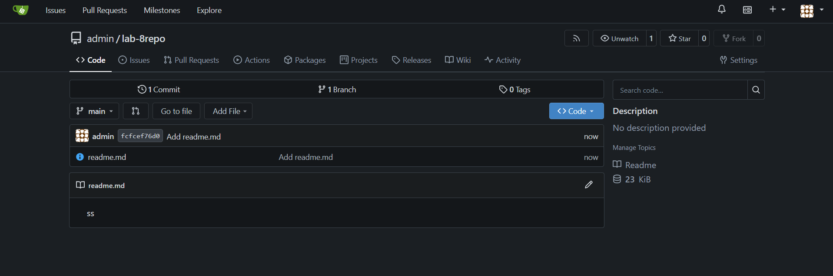
- Task 4 summary (combine evidence)
Save screenshot as: task4_summary.png — single screenshot (or tiled screenshot) showing: EC2 Instances list with Lab8Machine running and public IP, security group inbound rules showing SSH and port 3000, and browser tab open to Gitea UI or repo list.
task4_summary.png
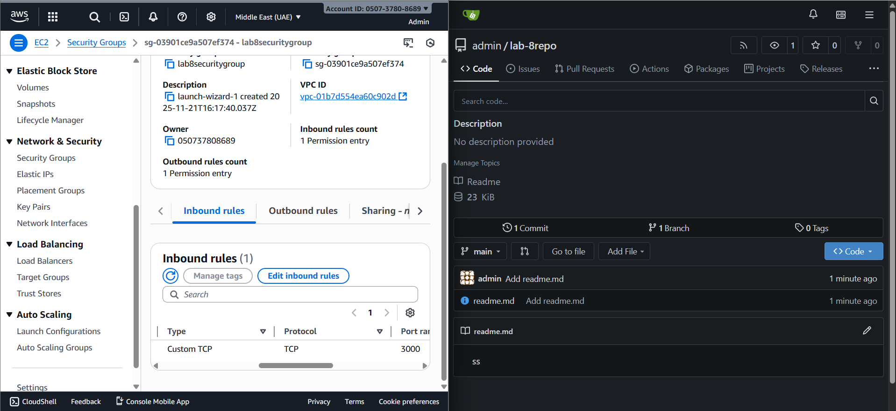
Cleanup — Remove resources to avoid charges

After verification, terminate and delete everything you created. Capture screenshots immediately after each cleanup step.
Cleanup steps and required screenshots:
- Terminate the EC2 instance Lab8Machine.
Save screenshot as: cleanup_terminate_instance.png — EC2 terminate instance confirmation.
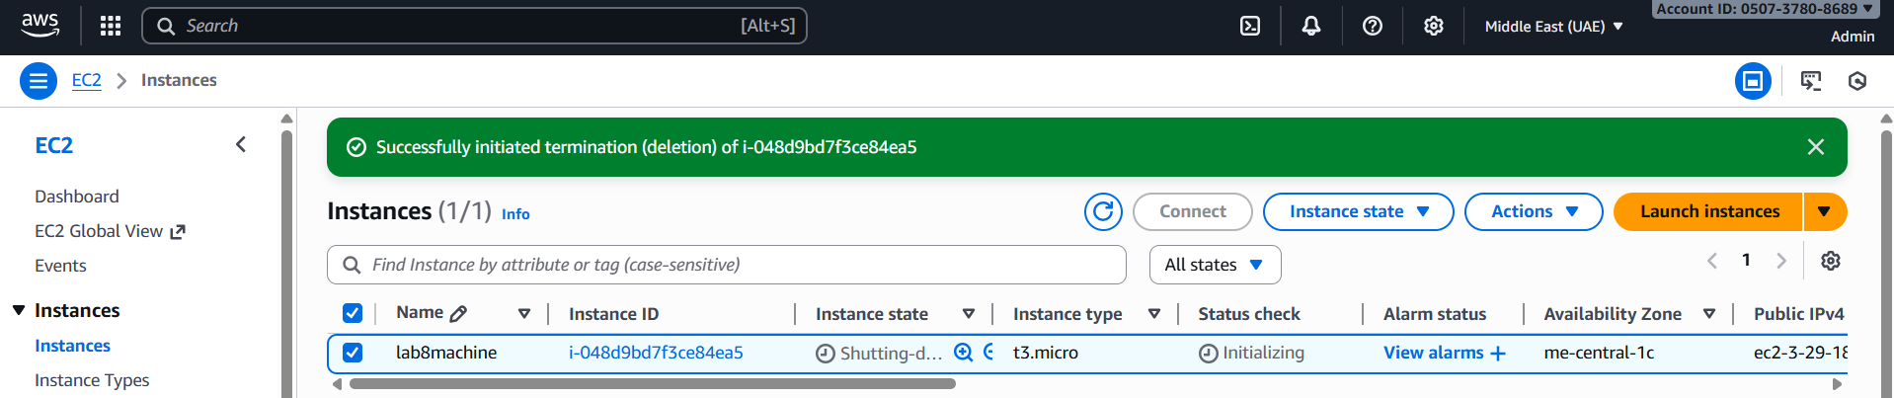
- Delete associated EBS volumes and snapshots (if any).
Save screenshot as: cleanup_delete_volumes_snapshots.png — confirmation or list showing volumes/snapshots deleted.
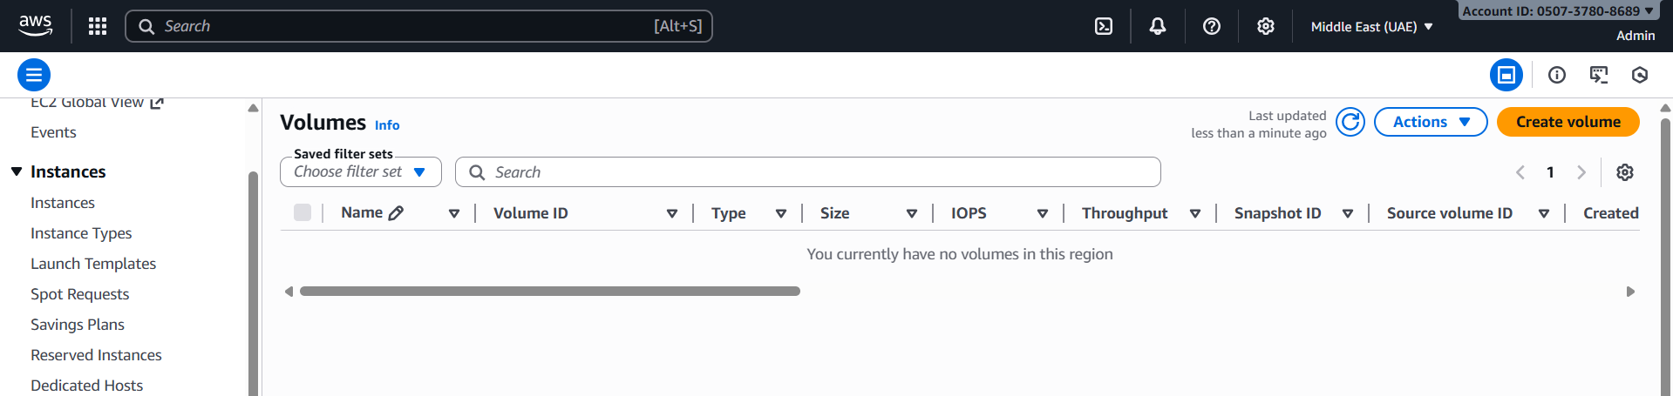
- Delete security group Lab8SecurityGroup and key pair Lab8Key from the EC2 console (after instances terminated).
Save screenshot as: cleanup_delete_security_group_and_keypair.png — deletion confirmation(s) (show key pair list and security group list after deletion).
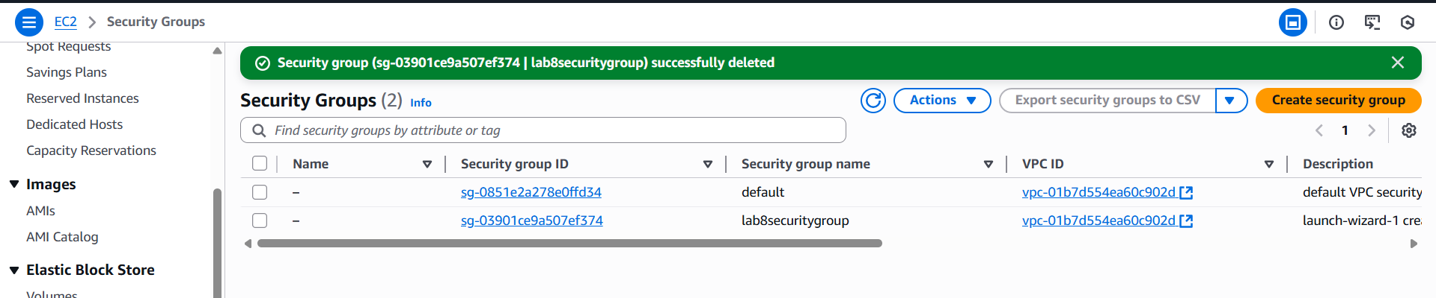
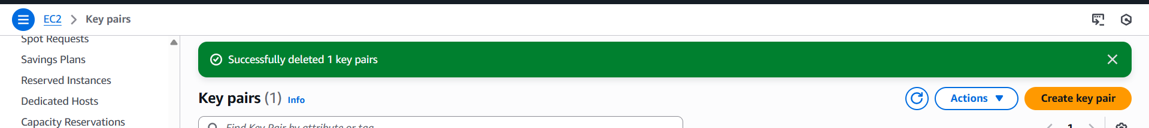
- Delete IAM users Lab8User and any access keys.
Save screenshot as: cleanup_iam_users_deleted.png — IAM Users list showing Admin and Lab8User no longer present (or a deletion confirmation).
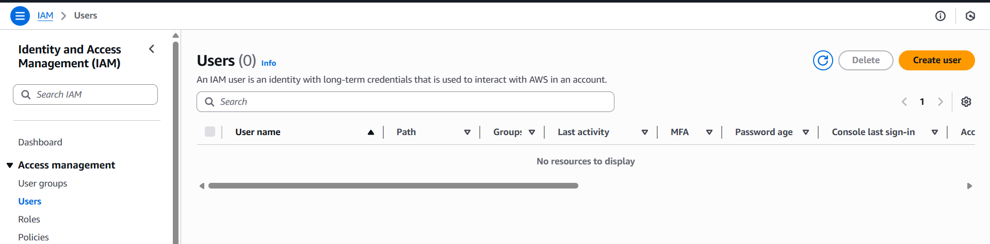
- Final cleanup summary (show billing or resource groups with no active resources if possible).
Save screenshot as: cleanup_summary.png — AWS console Billing/Resource Groups showing no active resources or no recent charges (if available).
